Orientation day for professors with additional
leadership roles at UZH

Dialogue event with the Executive Board of the University
18 October 2021, 3 - 8 pm

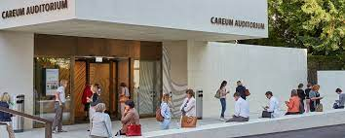
Auditorium Careum, Pestalozzistr. 11, 8032 Zürich

Zeit | Input | Thema
15.00 - 16.00 | Michael Schaepman  Gabriele Siegert  Rita Stöckli | UZH way of leadership
16.00 - 17.00 | Stefan Schnyder  François Chapuis | Finances, Human Resources and Real Estate, Facility Management
17.00 - 18.00 | Christian Schwarzenegger  Beatrice Beck-Schimmer | Faculty Affairs, Scientific Information and Medecine
18.00 - 19.00 | Elisabeth Stark  Gabriele Siegert | Research and Education
19.00 - 20.00 | Apéro riche

Reason Why
Assuming a leadership role at the UZH (such as Dean, Vice Dean, Head of Department, Director of an UFSP or NCCR) means for professors that they take over new and different tasks, compared to the tasks of their academic career.
The new role involves new responsibilities, which in some cases require additional skills. Leadership tasks and the diverse range of expectations of internal interest groups become more important in this context.

